Campaign Summary
Review of Formative Research
Situation
With our group consisting of myself, Julia Molnar, and Bethany Baldwin, we were assigned to work on an event to help Dayton Children’s Hospital. Our point of contact initially started with Laina Serrer from HPAC and Jessica Saunders, Director of the Office of Community Health and Engagement, from Dayton Children’s Hospital. After a few failed attempted meetings with Jessica Saunders, we discovered she had her plate full. Laina was able to connect us with Franki Meier, a Donor Engagement Specialist for Dayton Children’s Hospital.
Organization
Bethany, Julia, and I worked with Laina to decide the best way to work with Dayton Children’s Hospital. The problem we struggled with, was that we had no direction to go on. After researching the hospital’s recent events and activities, so we don’t repeat an event, we found an article about Sam’s Fans. Sam’s Fans is an organization based in Columbus that donated $10,000 to the music therapy program. Once we saw that, we found our direction. Based on our love of music, and the fact that the program was donor funded, we knew we had a platform, creating a benefit concert. After brainstorming many ideas, we found one that would work for everyone involved. Franki was able to meet with us and discuss all the ways we are and aren’t able to promote the event when using Dayton Children’s Hospital. Their brand is special and they do all they can to protect it, which is understandable.
Publics
Our plan to build a benefit concert is focused on bringing in as many people in the Dayton Community as we can. We didn’t stop there though! Using social media, we were able to reach the audience that extends global, by starting the fundraiser a month prior to do a few things; our biggest goal was to bring attention to the cause, our second goal was to raise money for the hospital through their fundraiser set up on their Facebook page. Now we are networking with everyone we know on social media, plus raising money at the event itself.
Justifying Team/Campaign Strategy
Goals and Objectives
We had a number of goals to achieve. Our first goal was to figure out a venue and a band. With the introduction to Bethany’s brother, a music promoter in Dayton, we were able to reach out to several bands and a few venues. Ultimately, we booked our event through Brightside Music & Events Venue, where they were excited to donate the venue itself at no cost to us. We were also successful in booking not one, but four musicians/bands also donating their time and talent, to perform the night of the event. We wanted to at least get the Clarion to write a piece about our event and see if that was able to generate any interest. We also wanted to see if we could get the Guitar Lab to donate a guitar for us to donate to the hospital. Lastly, we had goals for the money we raised/raising awareness to the cause. For both the Facebook portion of the fundraiser, and the event ticket sales, we wanted to raise $500 from each outlet while talking about the music therapy program and informing the community on it being donor based.
Action and Response Strategies
For the eight or so weeks before our event, we worked on promoting our benefit concert anywhere we could. We also met with the bands and venue to work on the things that needed to be figured out before the concert. When meeting with the venue, we discovered we needed to figure out sound. After meeting with the sound organizer, Libby Ballengee, we discovered a meeting with the bands was a must in order to figure out stage plotting, a map of the stage and where each instrument, amp, and microphone would need to be placed. She also promoted the event on the Brightside Facebook page.
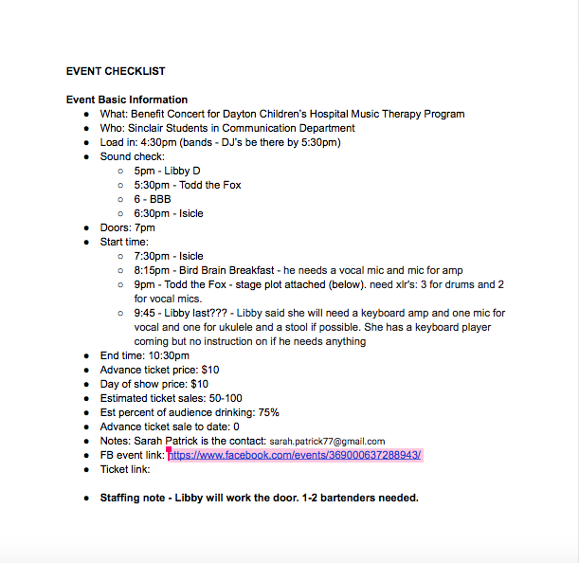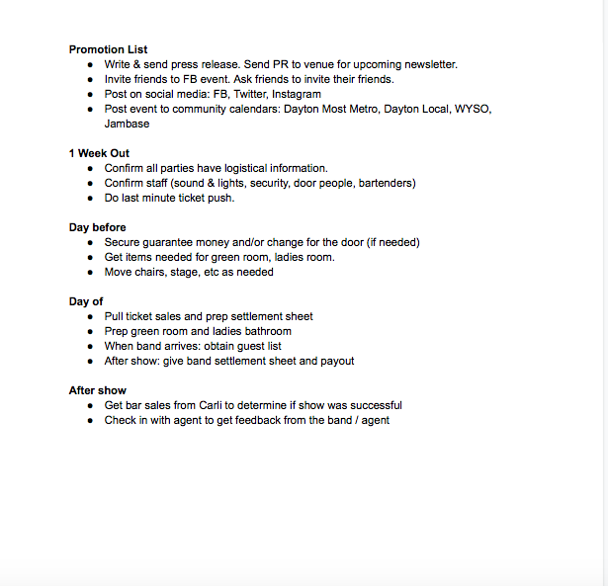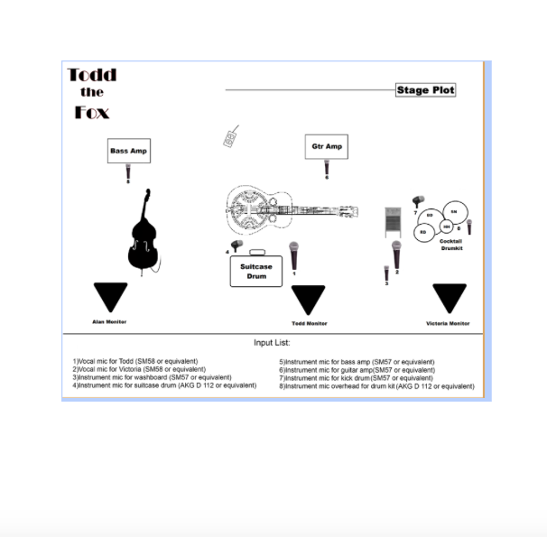
While planning our event, we also presented our plan to reach out to the community at HPAC’s Scholar’s Day event. This event was a good way to not only bring awareness to those who came, but also to help us promote our benefit concert.
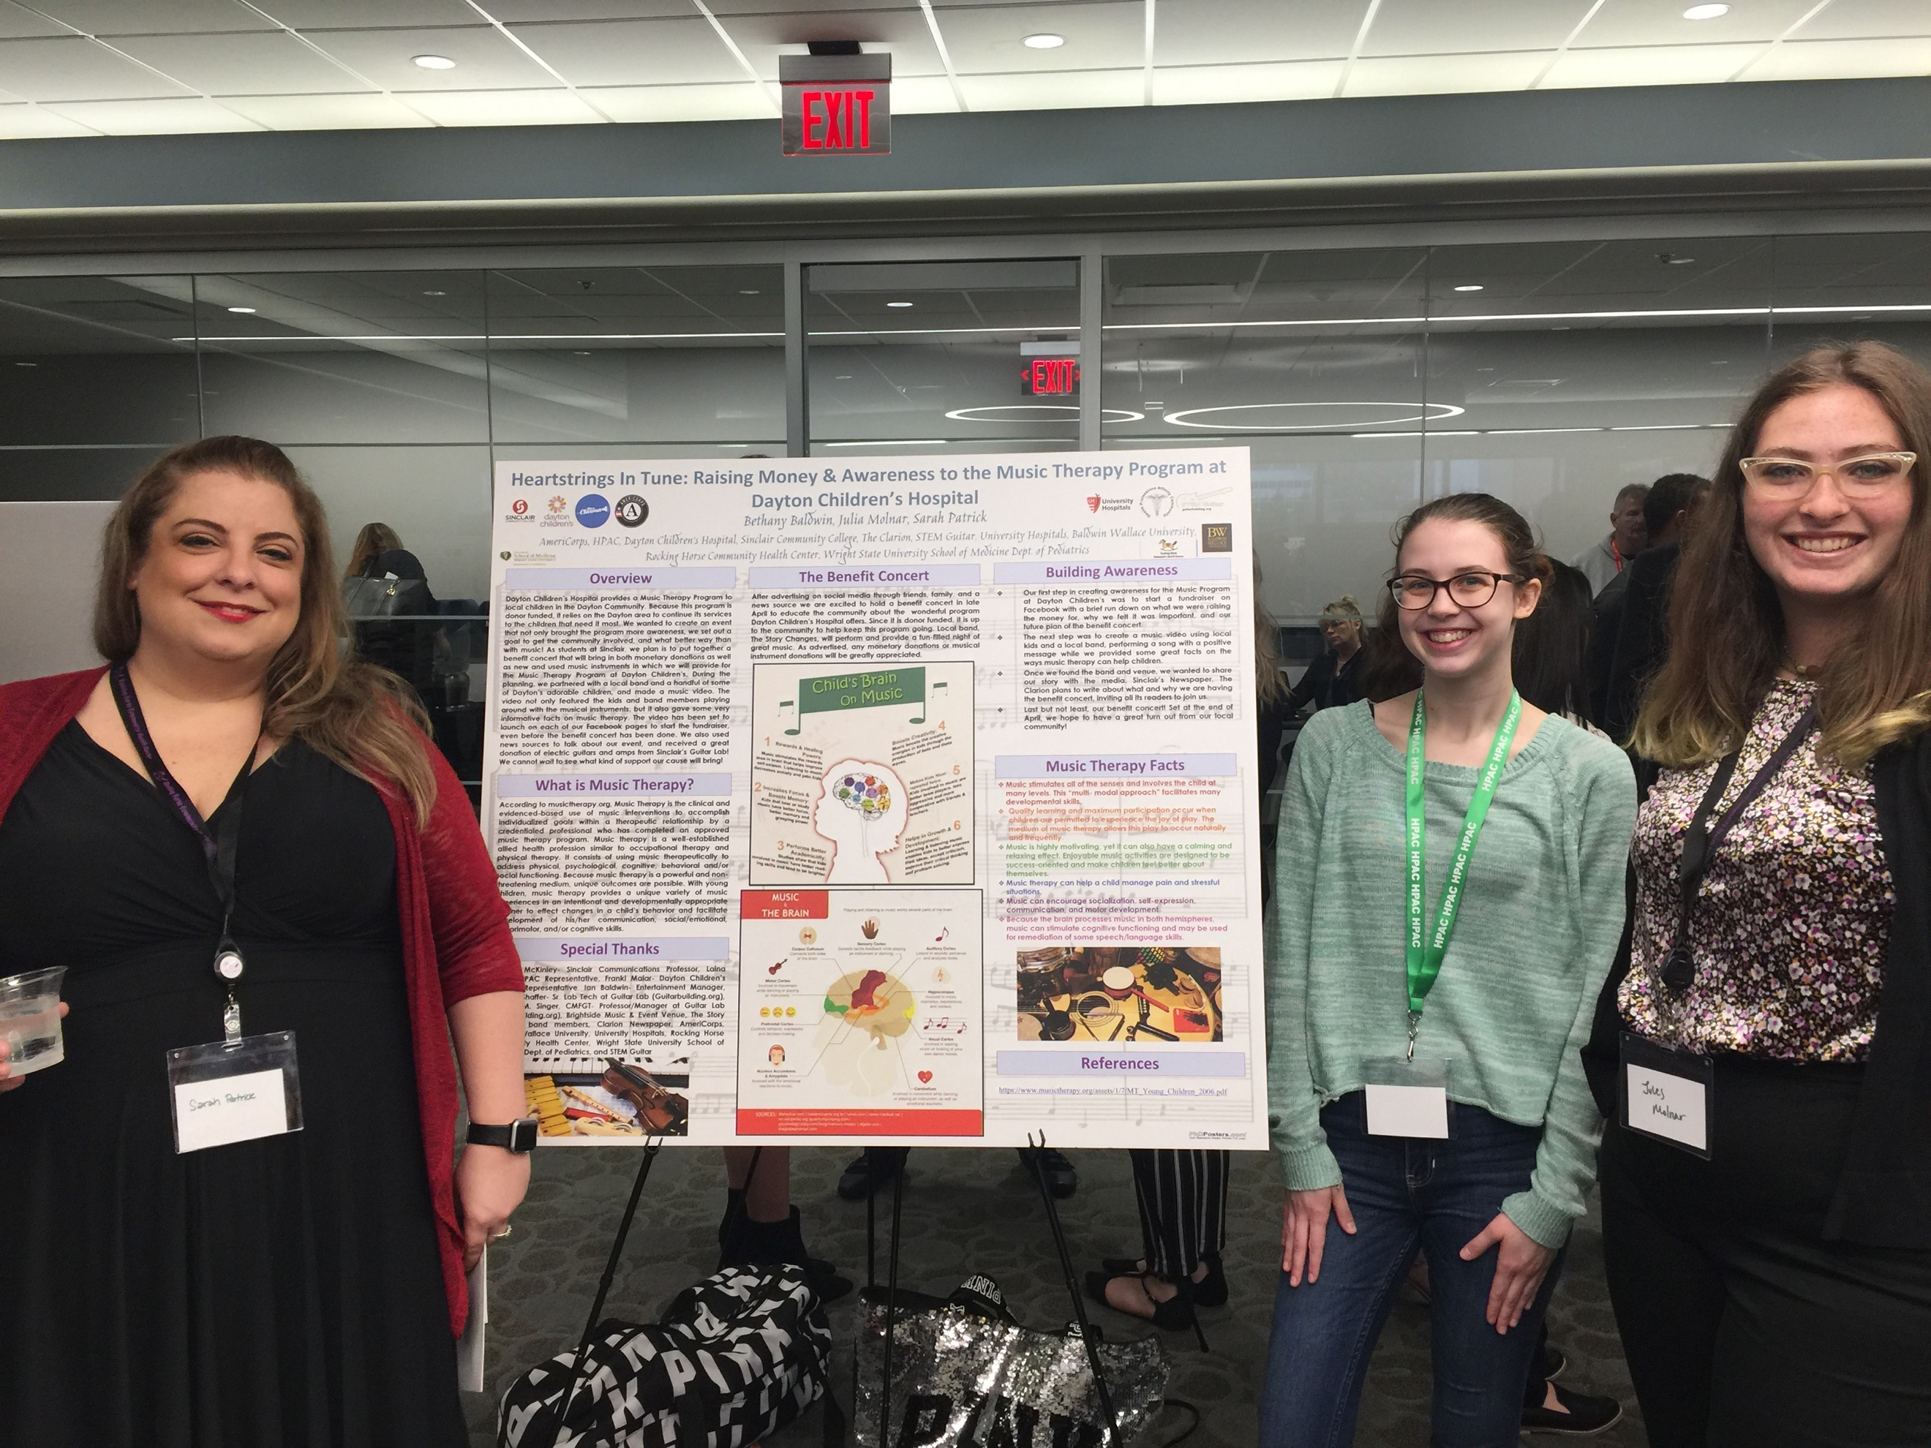
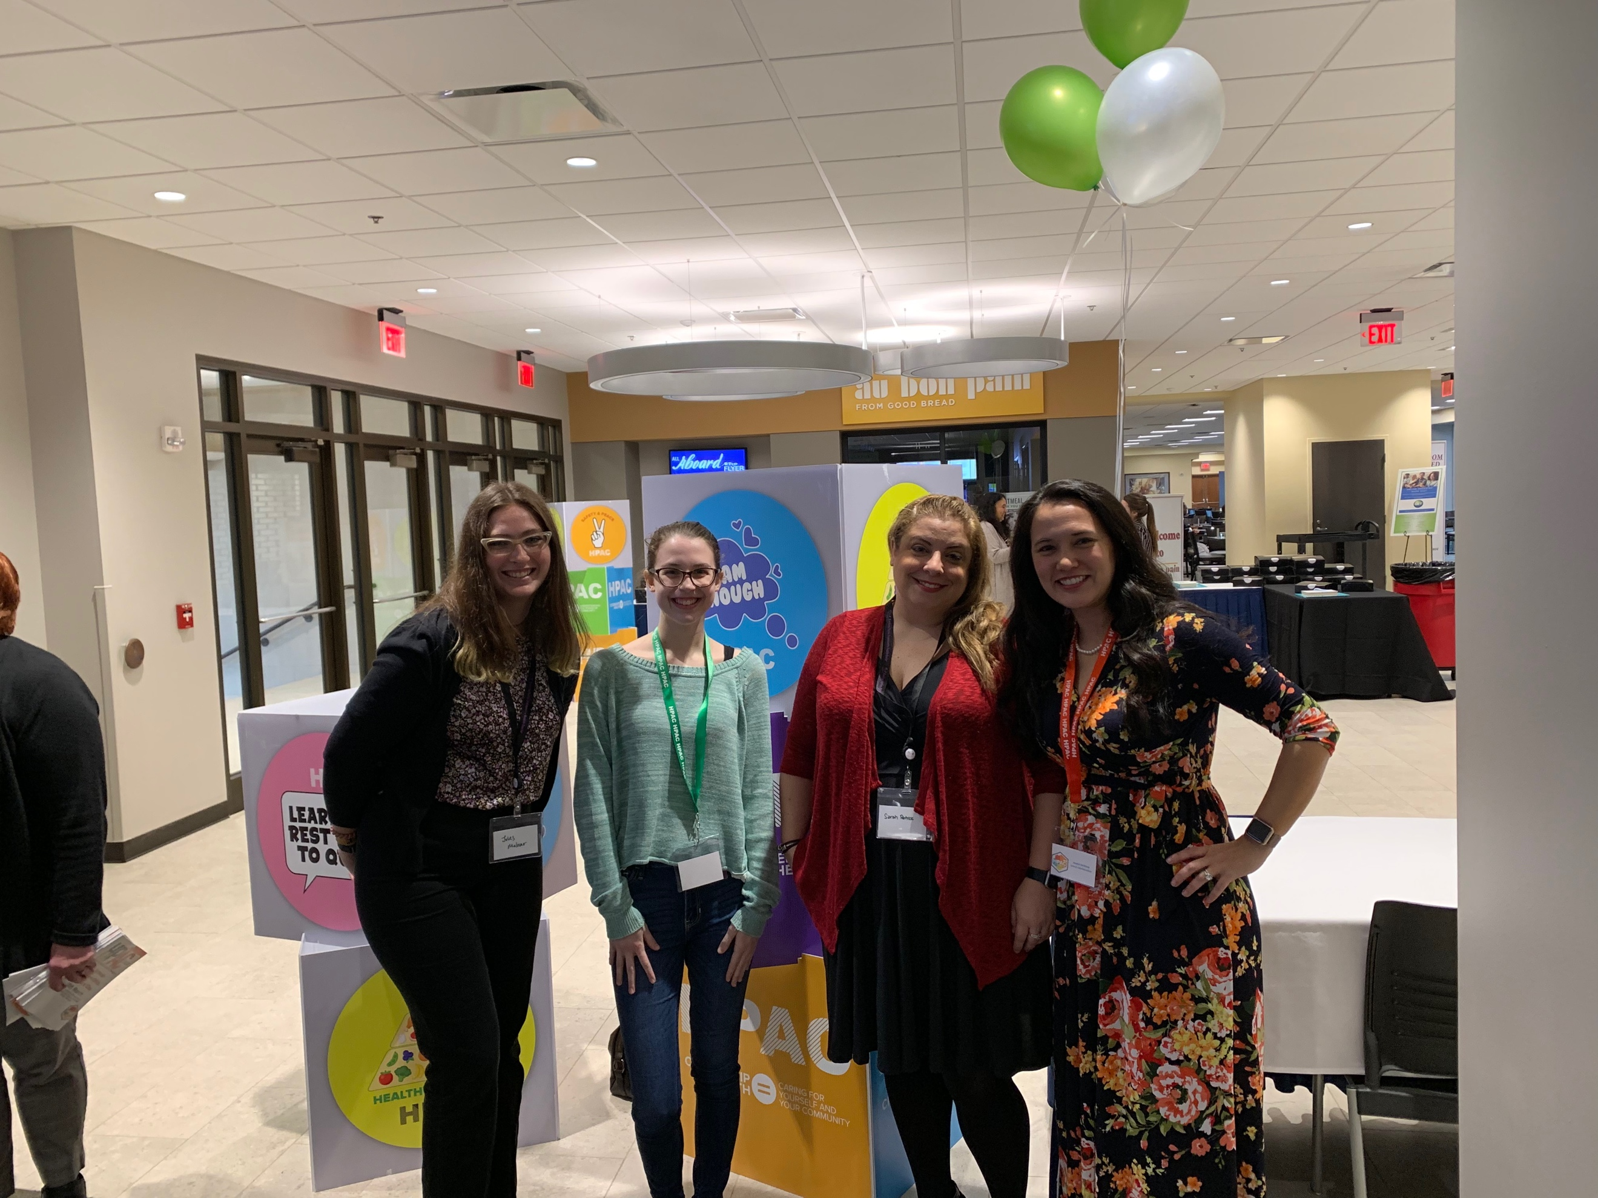
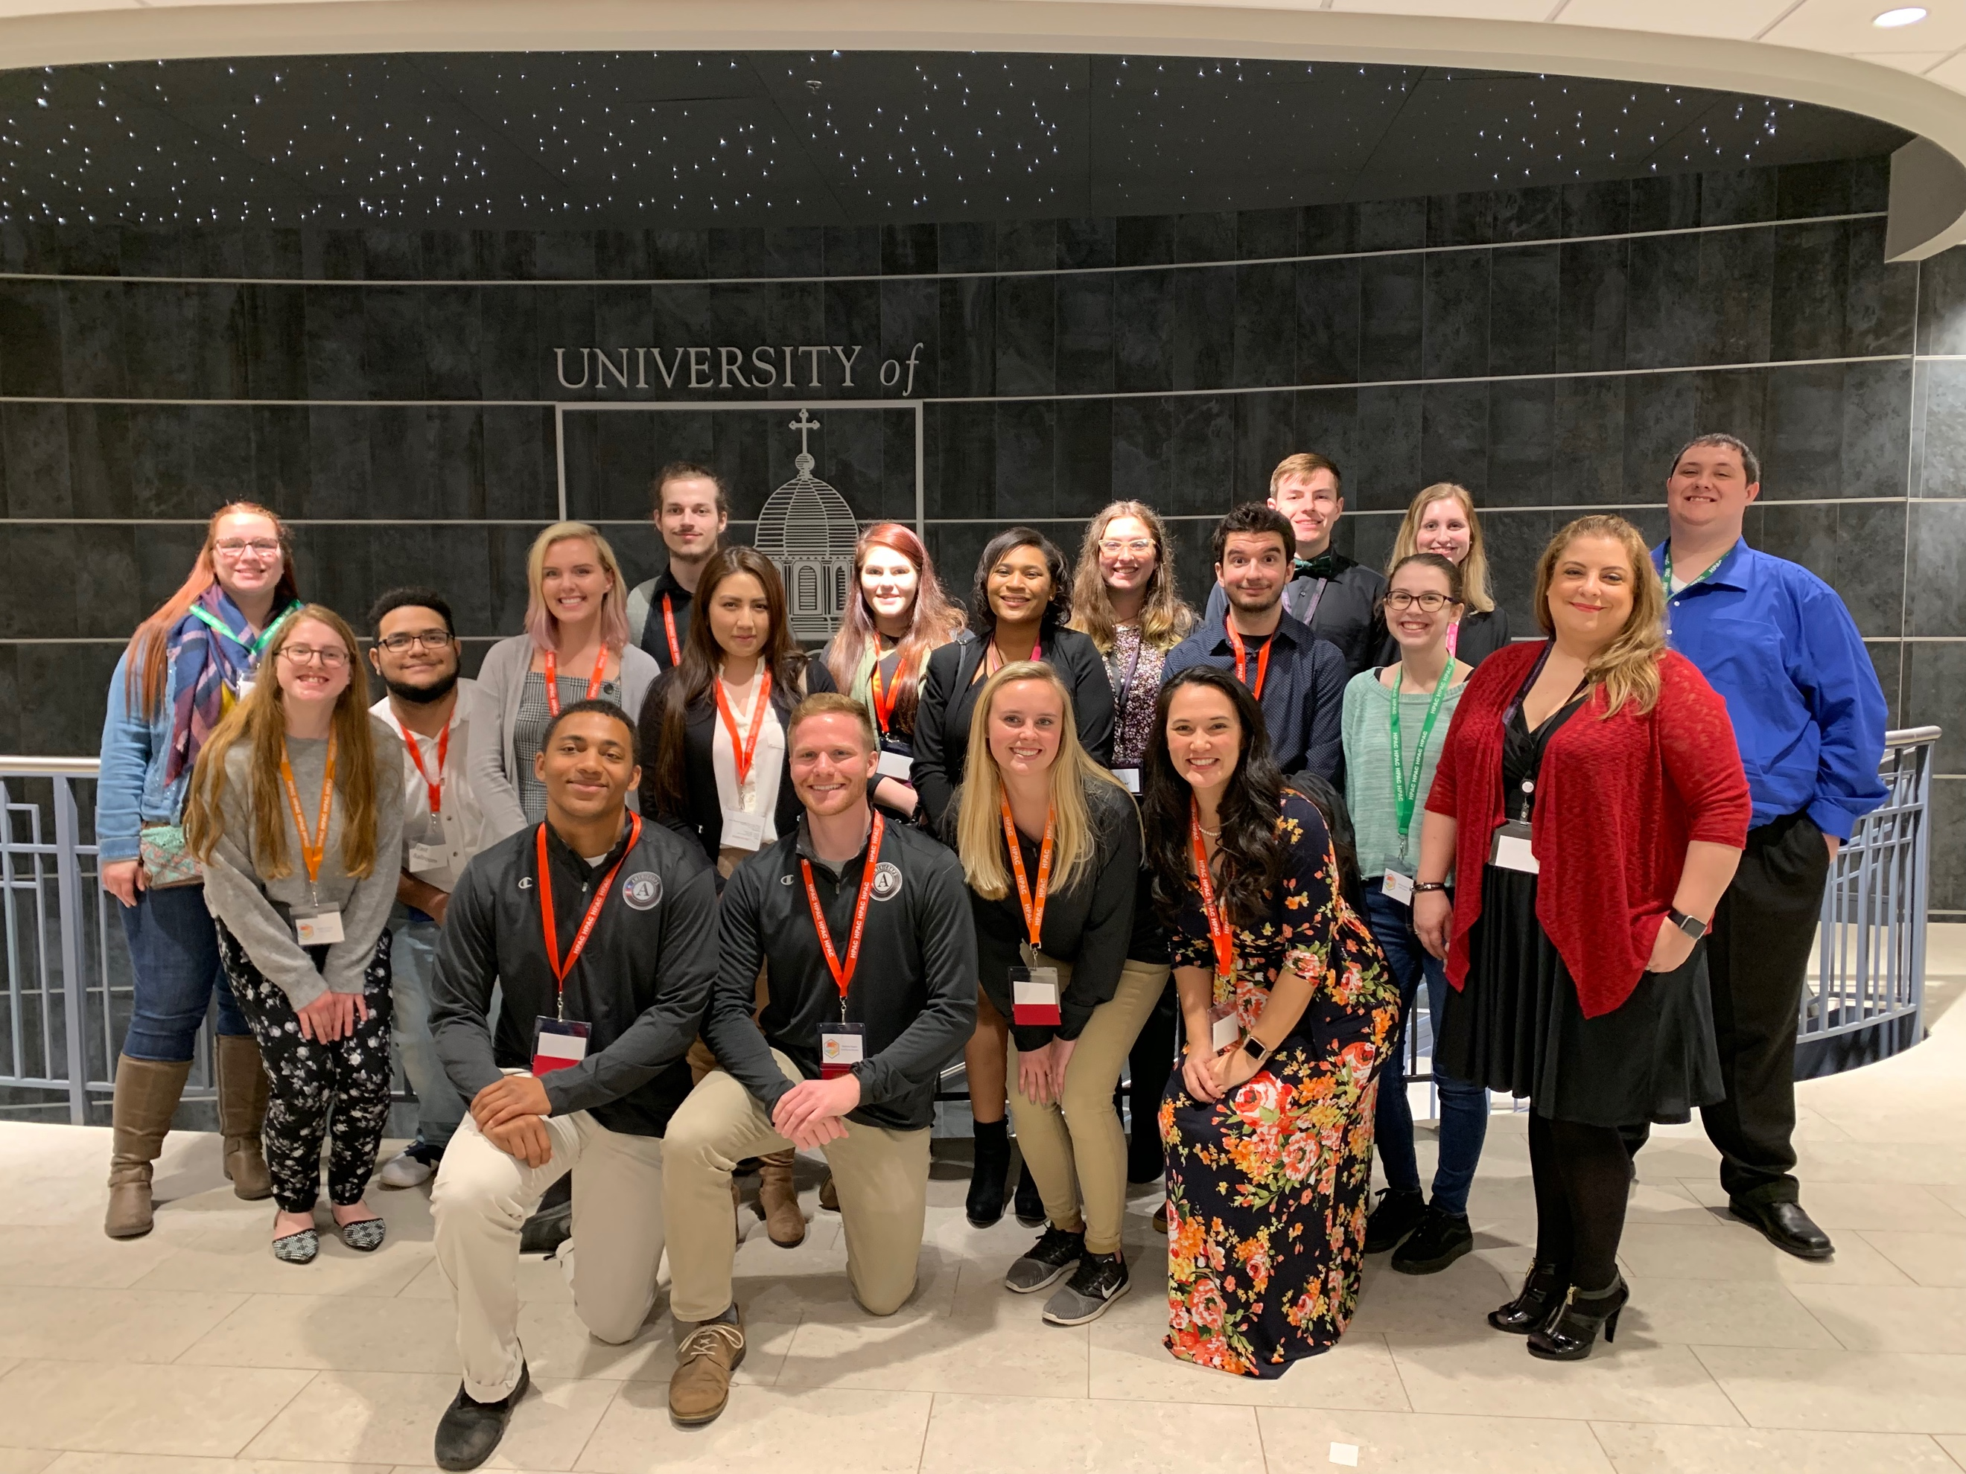
Effective Communication
We were able to get most of our planning done through group chats in text message, emails, and also by using Facebook messenger. We had one line of communication with all the bands. Another line of communication with each other, to discuss what we need done and checking off our tasks. Laina and Franki preferred a group email string, which I was tasked to keep up with. I also worked directly with Libby, making sure she had all the information she needed from the bands before the night of the show.
Showcase the Tactics used within the Campaign
Communication Tactics
Our biggest generator of views was social media. We used a flyer to promote the event on Facebook, Instagram, and Twitter. Those three places gained us a lot of attention, with many showing either attending or interested. We also had it linked to the Dayton Children’s Hospital Facebook page where they have over 40,000 followers.
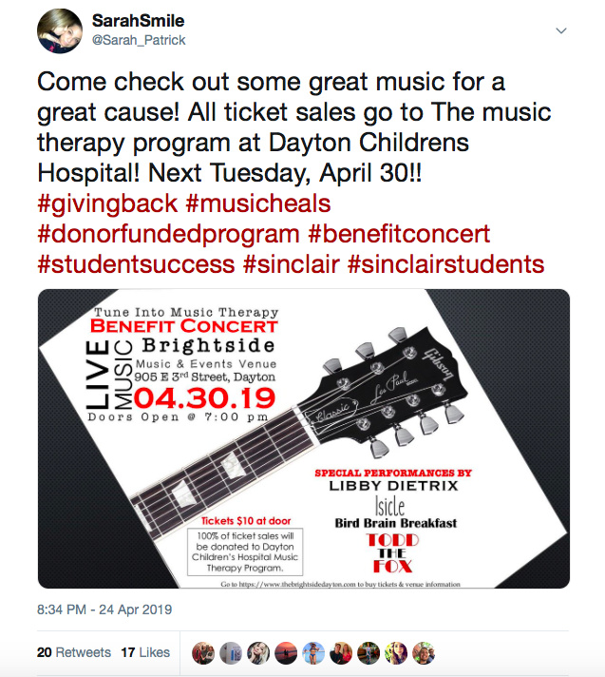
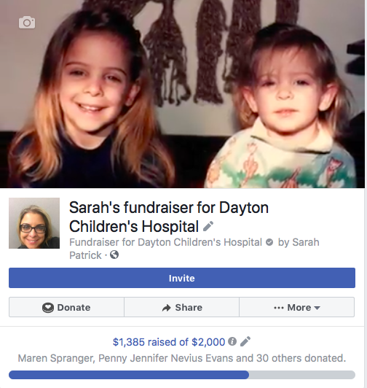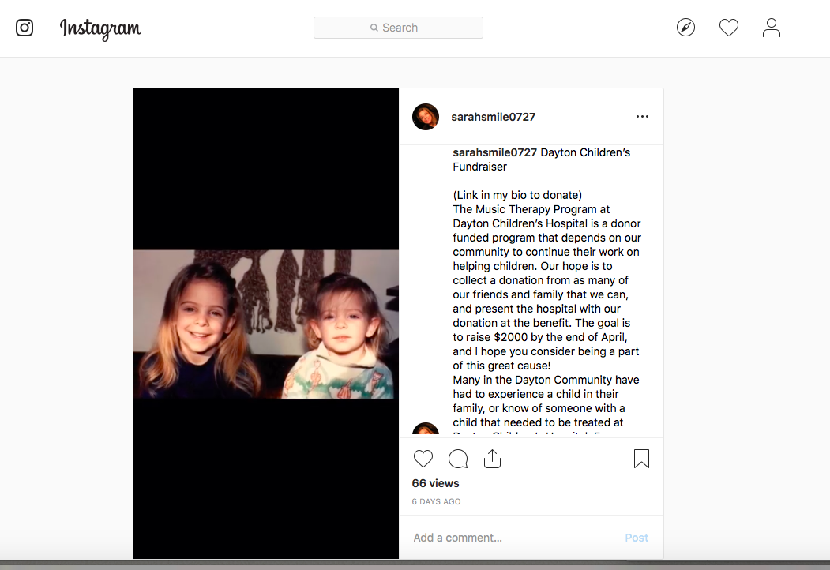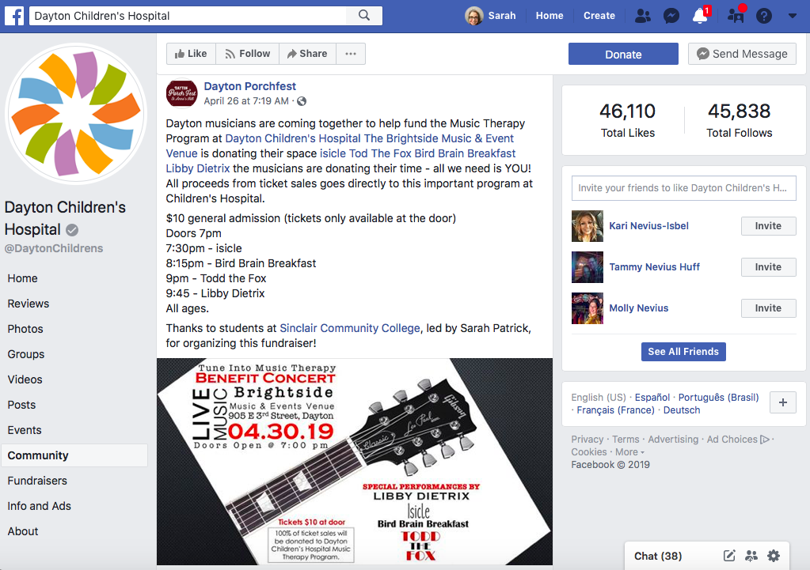
They have a large number of followers!
We were able to get a piece written witht The Clarion highlighting the journey we took while planning such an event, everyone involved, and the cause we chose to promote. It was full of details, leaving no question this was not just a great accomplishment for us students, but also great success for the Dayton Community and Dayton Children’s Hospital. An added surprise to the event was the donation of an electric guitar kit from the Guitar Lab. As we learned through the planning, not all our goals will likely to be met, many will just simply fail. With the back and forth phone tag, email tag, and just plain missing each other in the building, I didn’t think I was going to be able to get the guitar from them. They shocked me when I finally got in touch with them and they had it ready to go. We were able to take it to the benefit concert and have everyone sign it so we could present it with the money raised for Dayton Children’s Hospital. The Guitar Lab was even able to mentioned in The Clarion article.

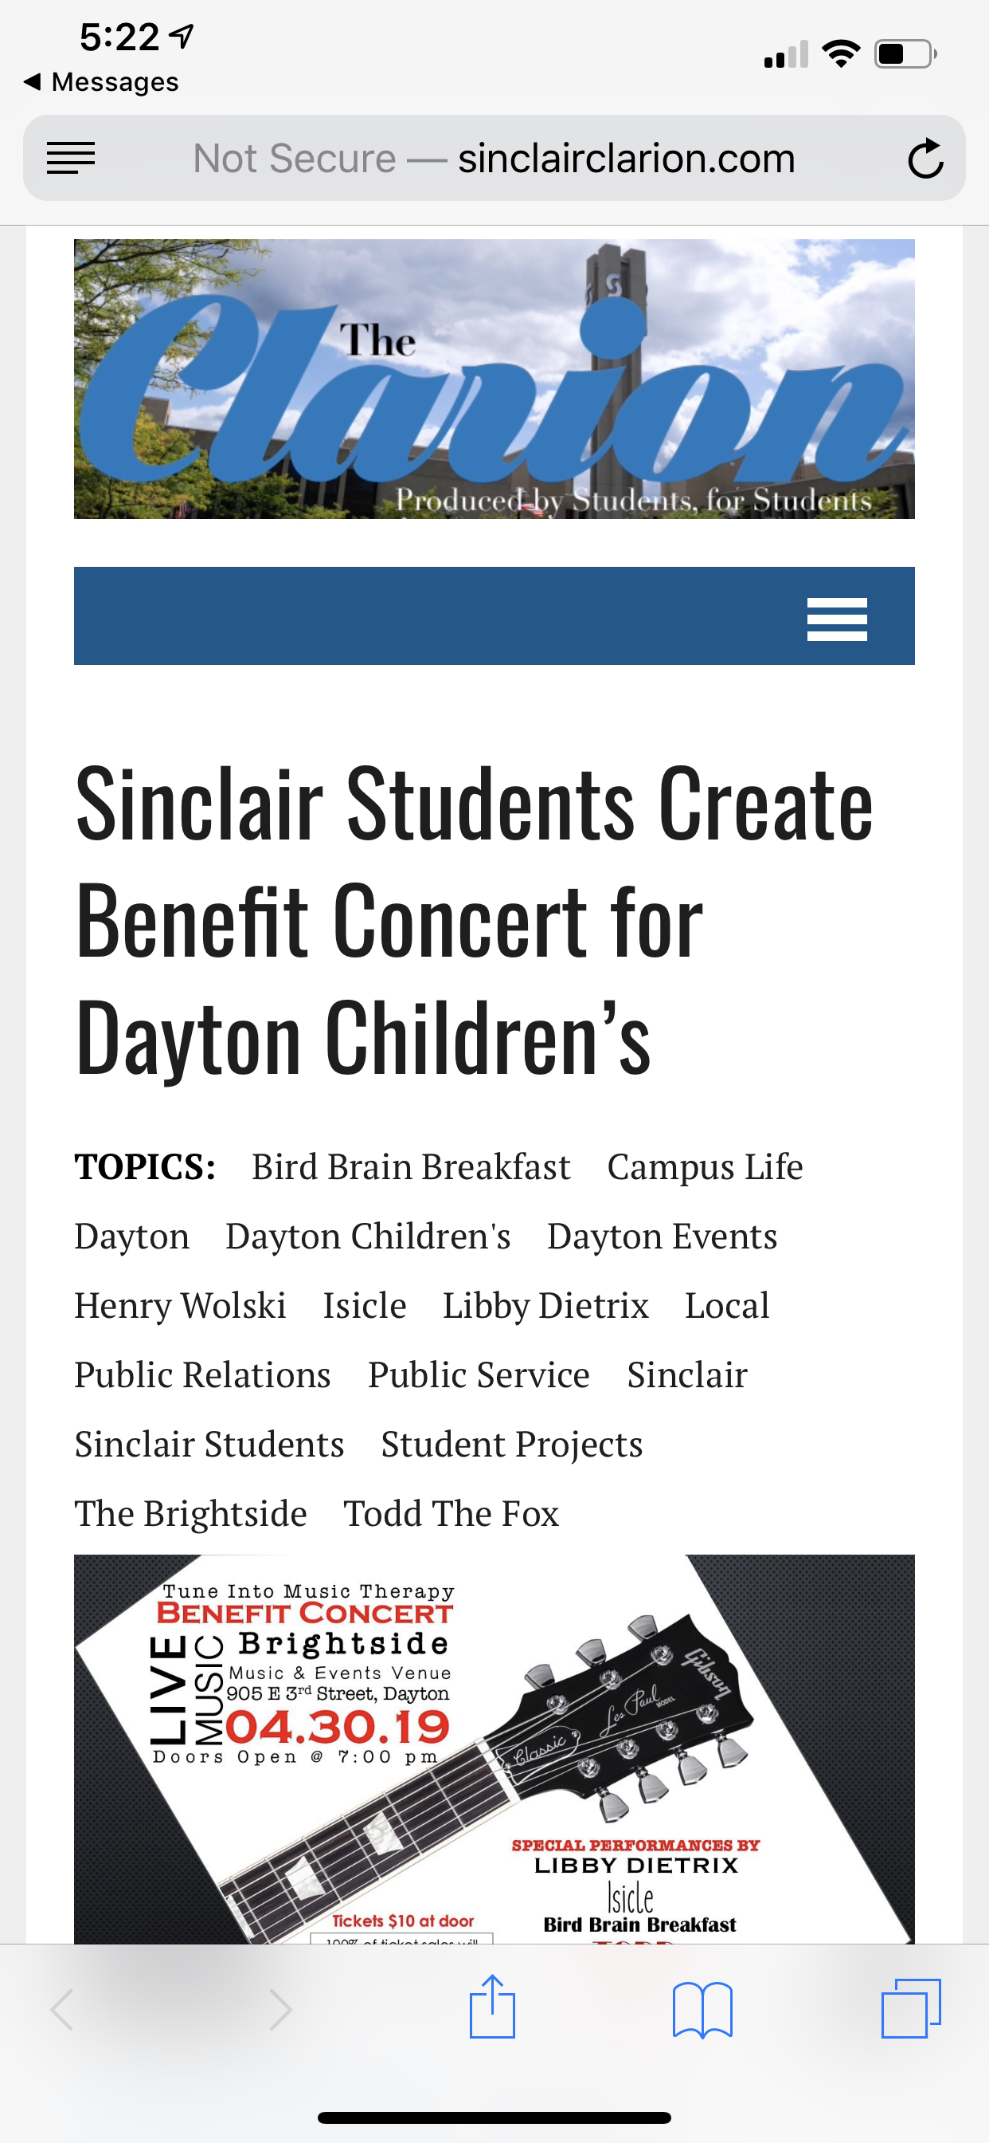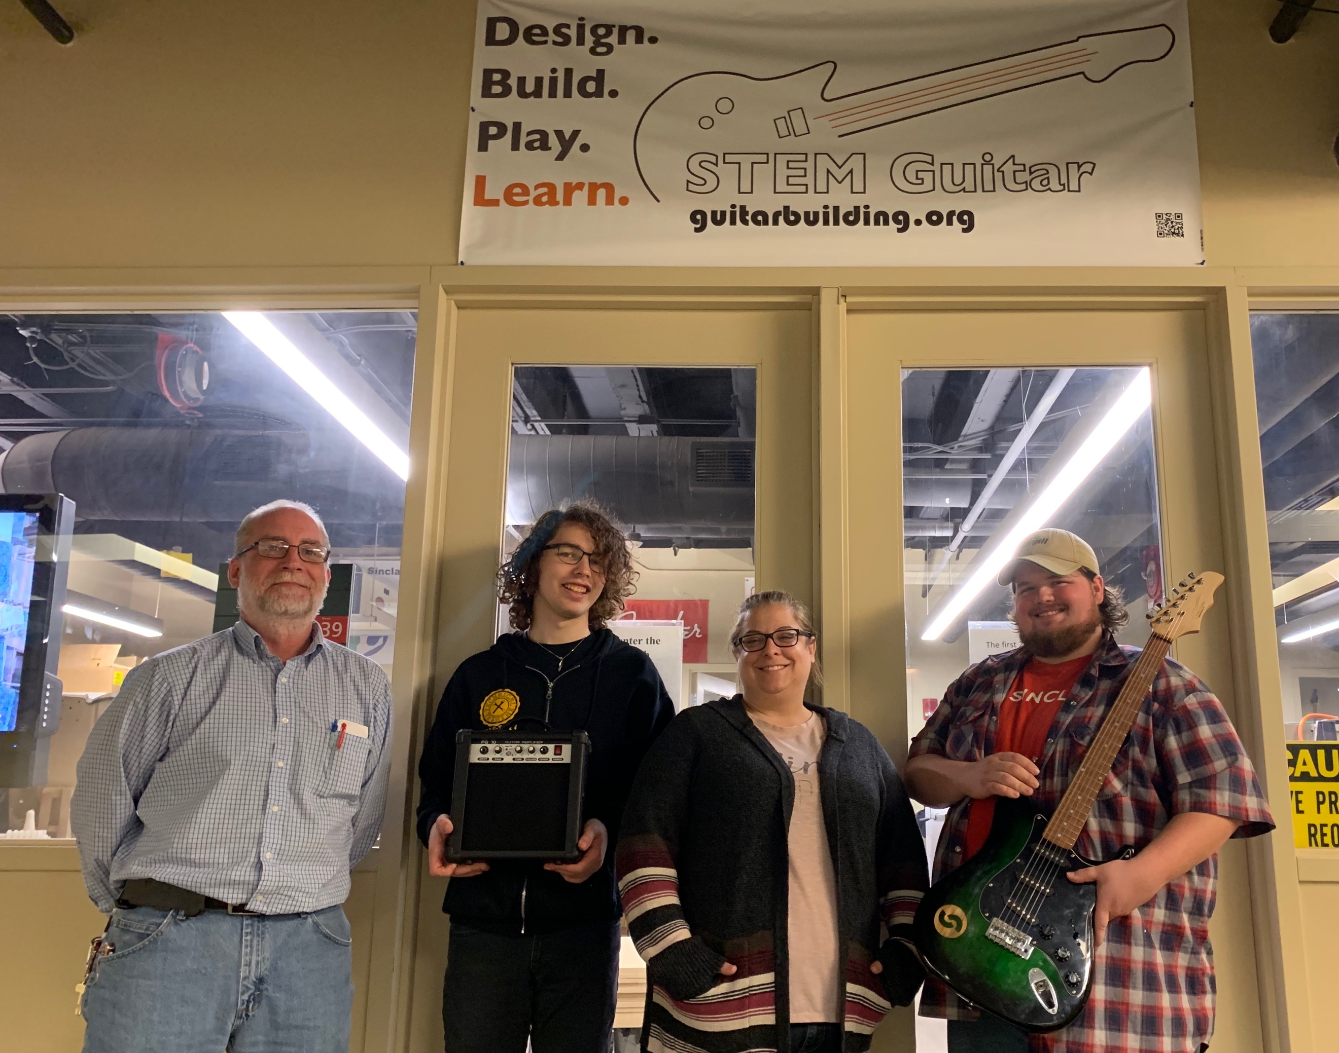
Strategic Plan
On the day of our benefit concert, Bethany, Julia, and I gave our presentation to the class, and then swiftly drove to the venue, as it was the same day as the benefit concert. With sound check completed and our guests arriving, we managed to keep our nerves mostly in check while socializing and networking with our guests. Once our speech was made, thanking everyone who donated their time and talent to organizing the event, we then thanked everyone who came to support us and our cause, as well as the donors from our Facebook fundraiser. The bands played their sets and sounded amazing, while fans cheered, danced, and sang along. With our opener, Isicle getting everyone warmed up and smiling with drinks in hand, to Bird Brain Breakfast strumming to his lyrical voice about hearts that hurt, to Libby and Aiden strumming and tinkling the ivories of the piano while singing in harmony, all the way to the closing performances of Todd the Fox, our favorite rockabilly band that had everyone on their feet. It was an overall wonderful night.
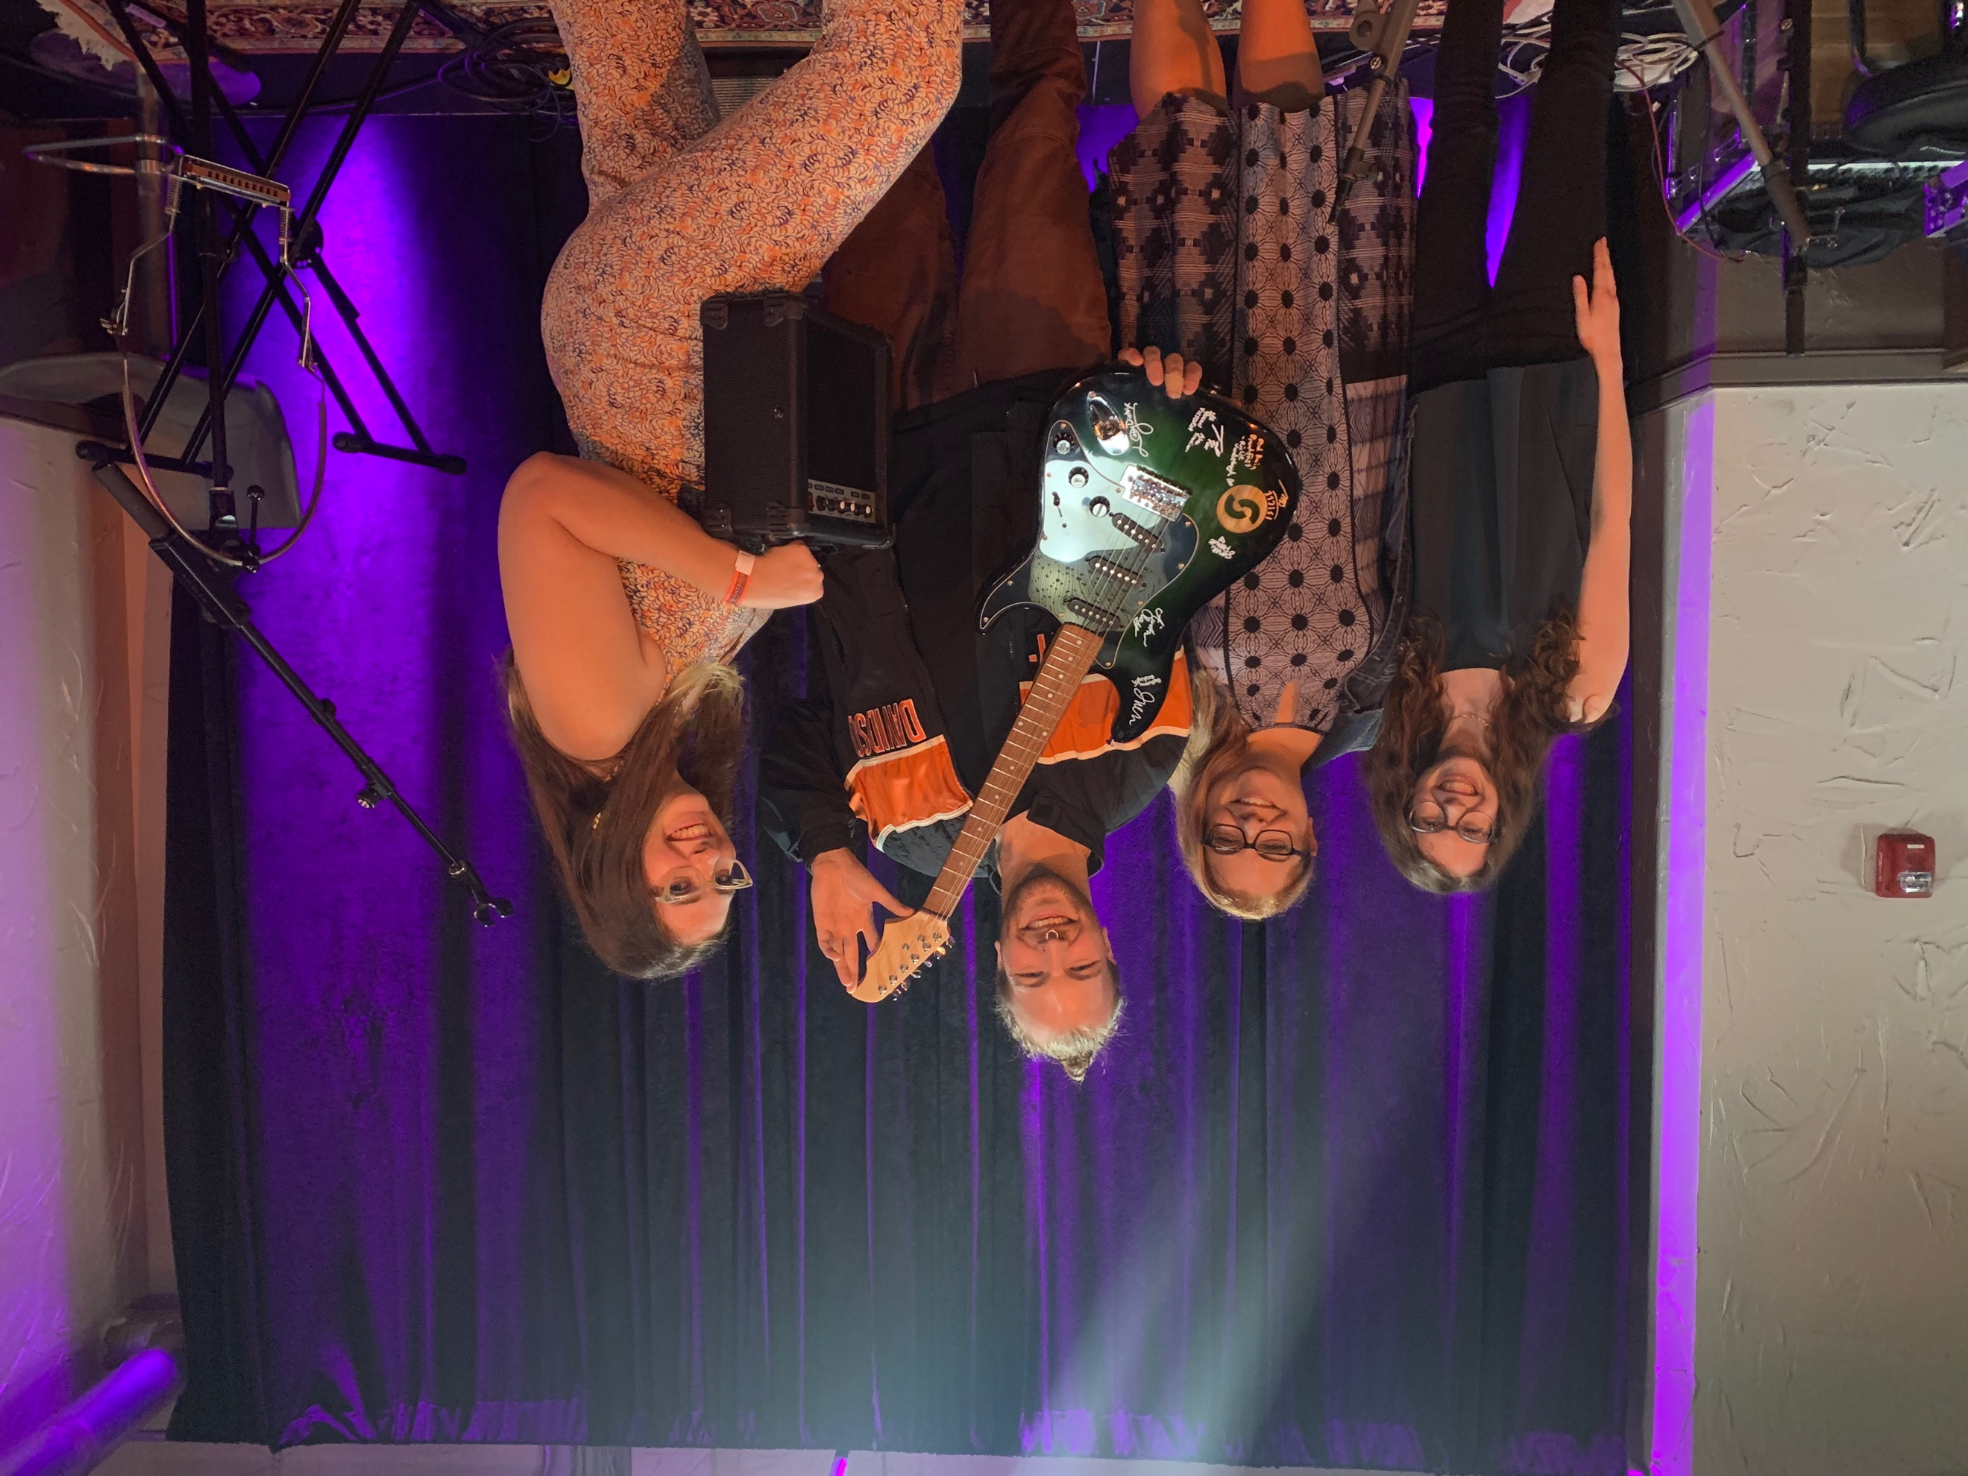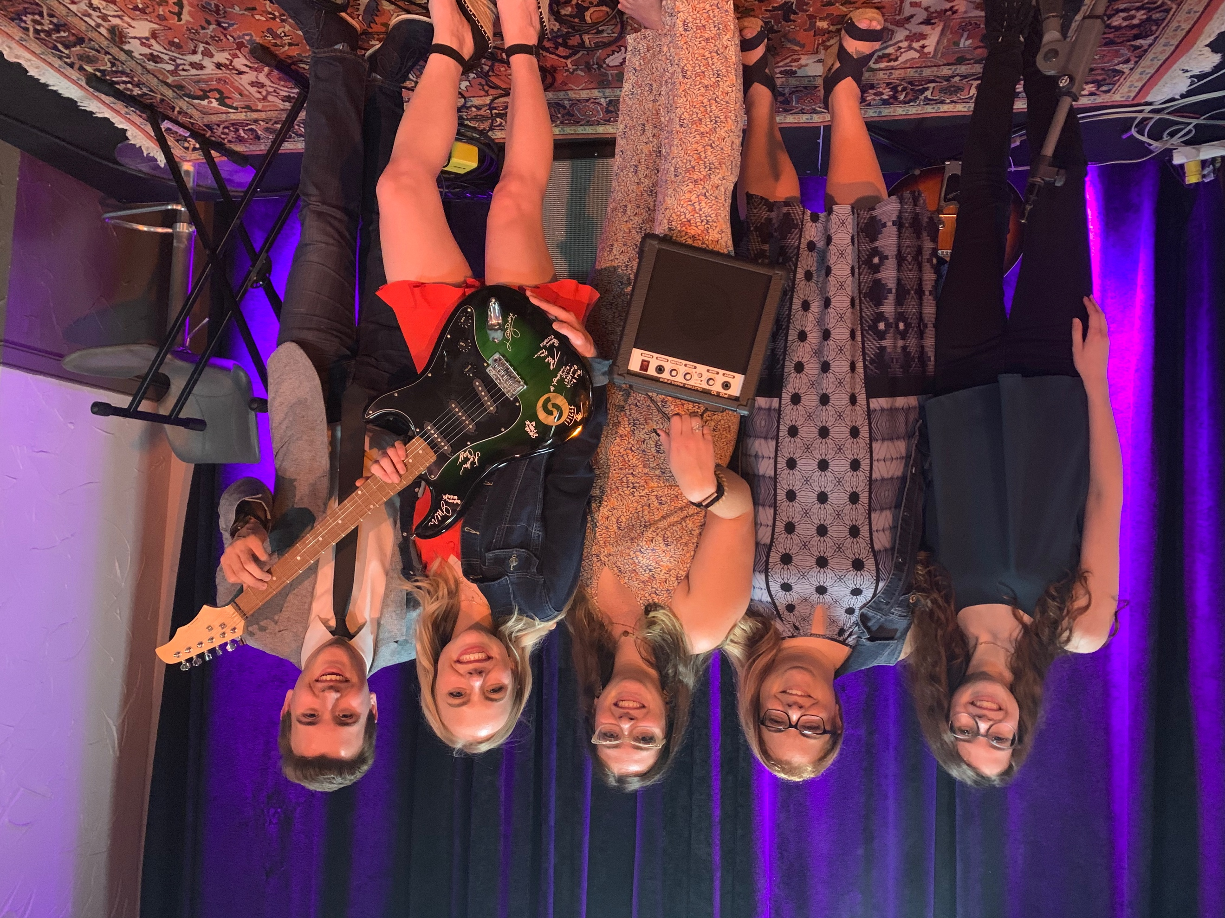
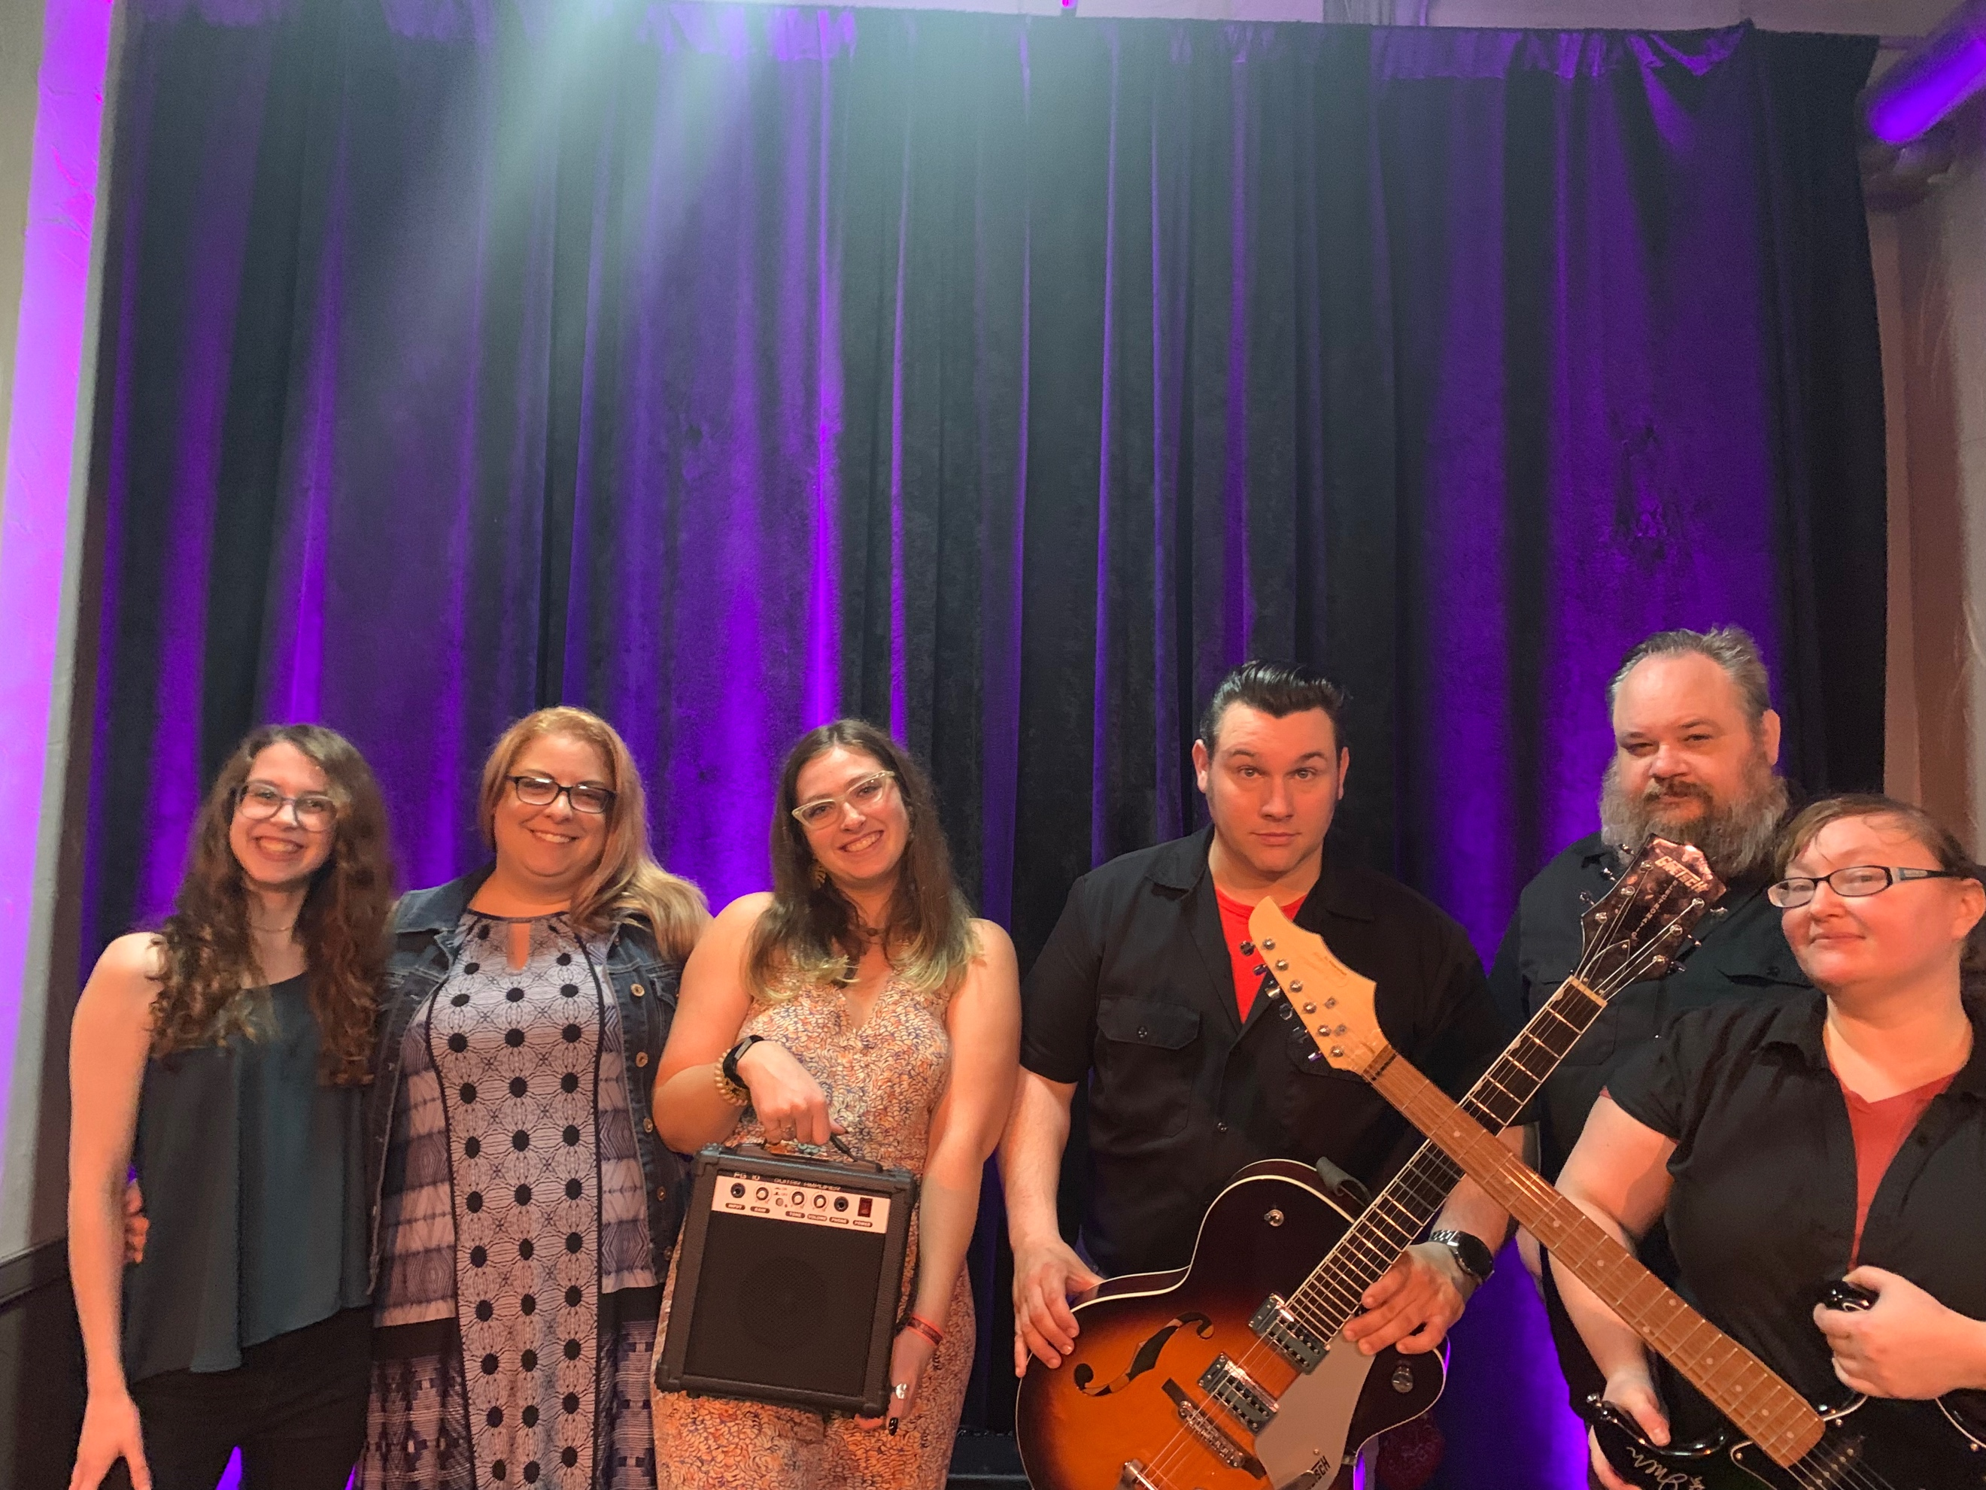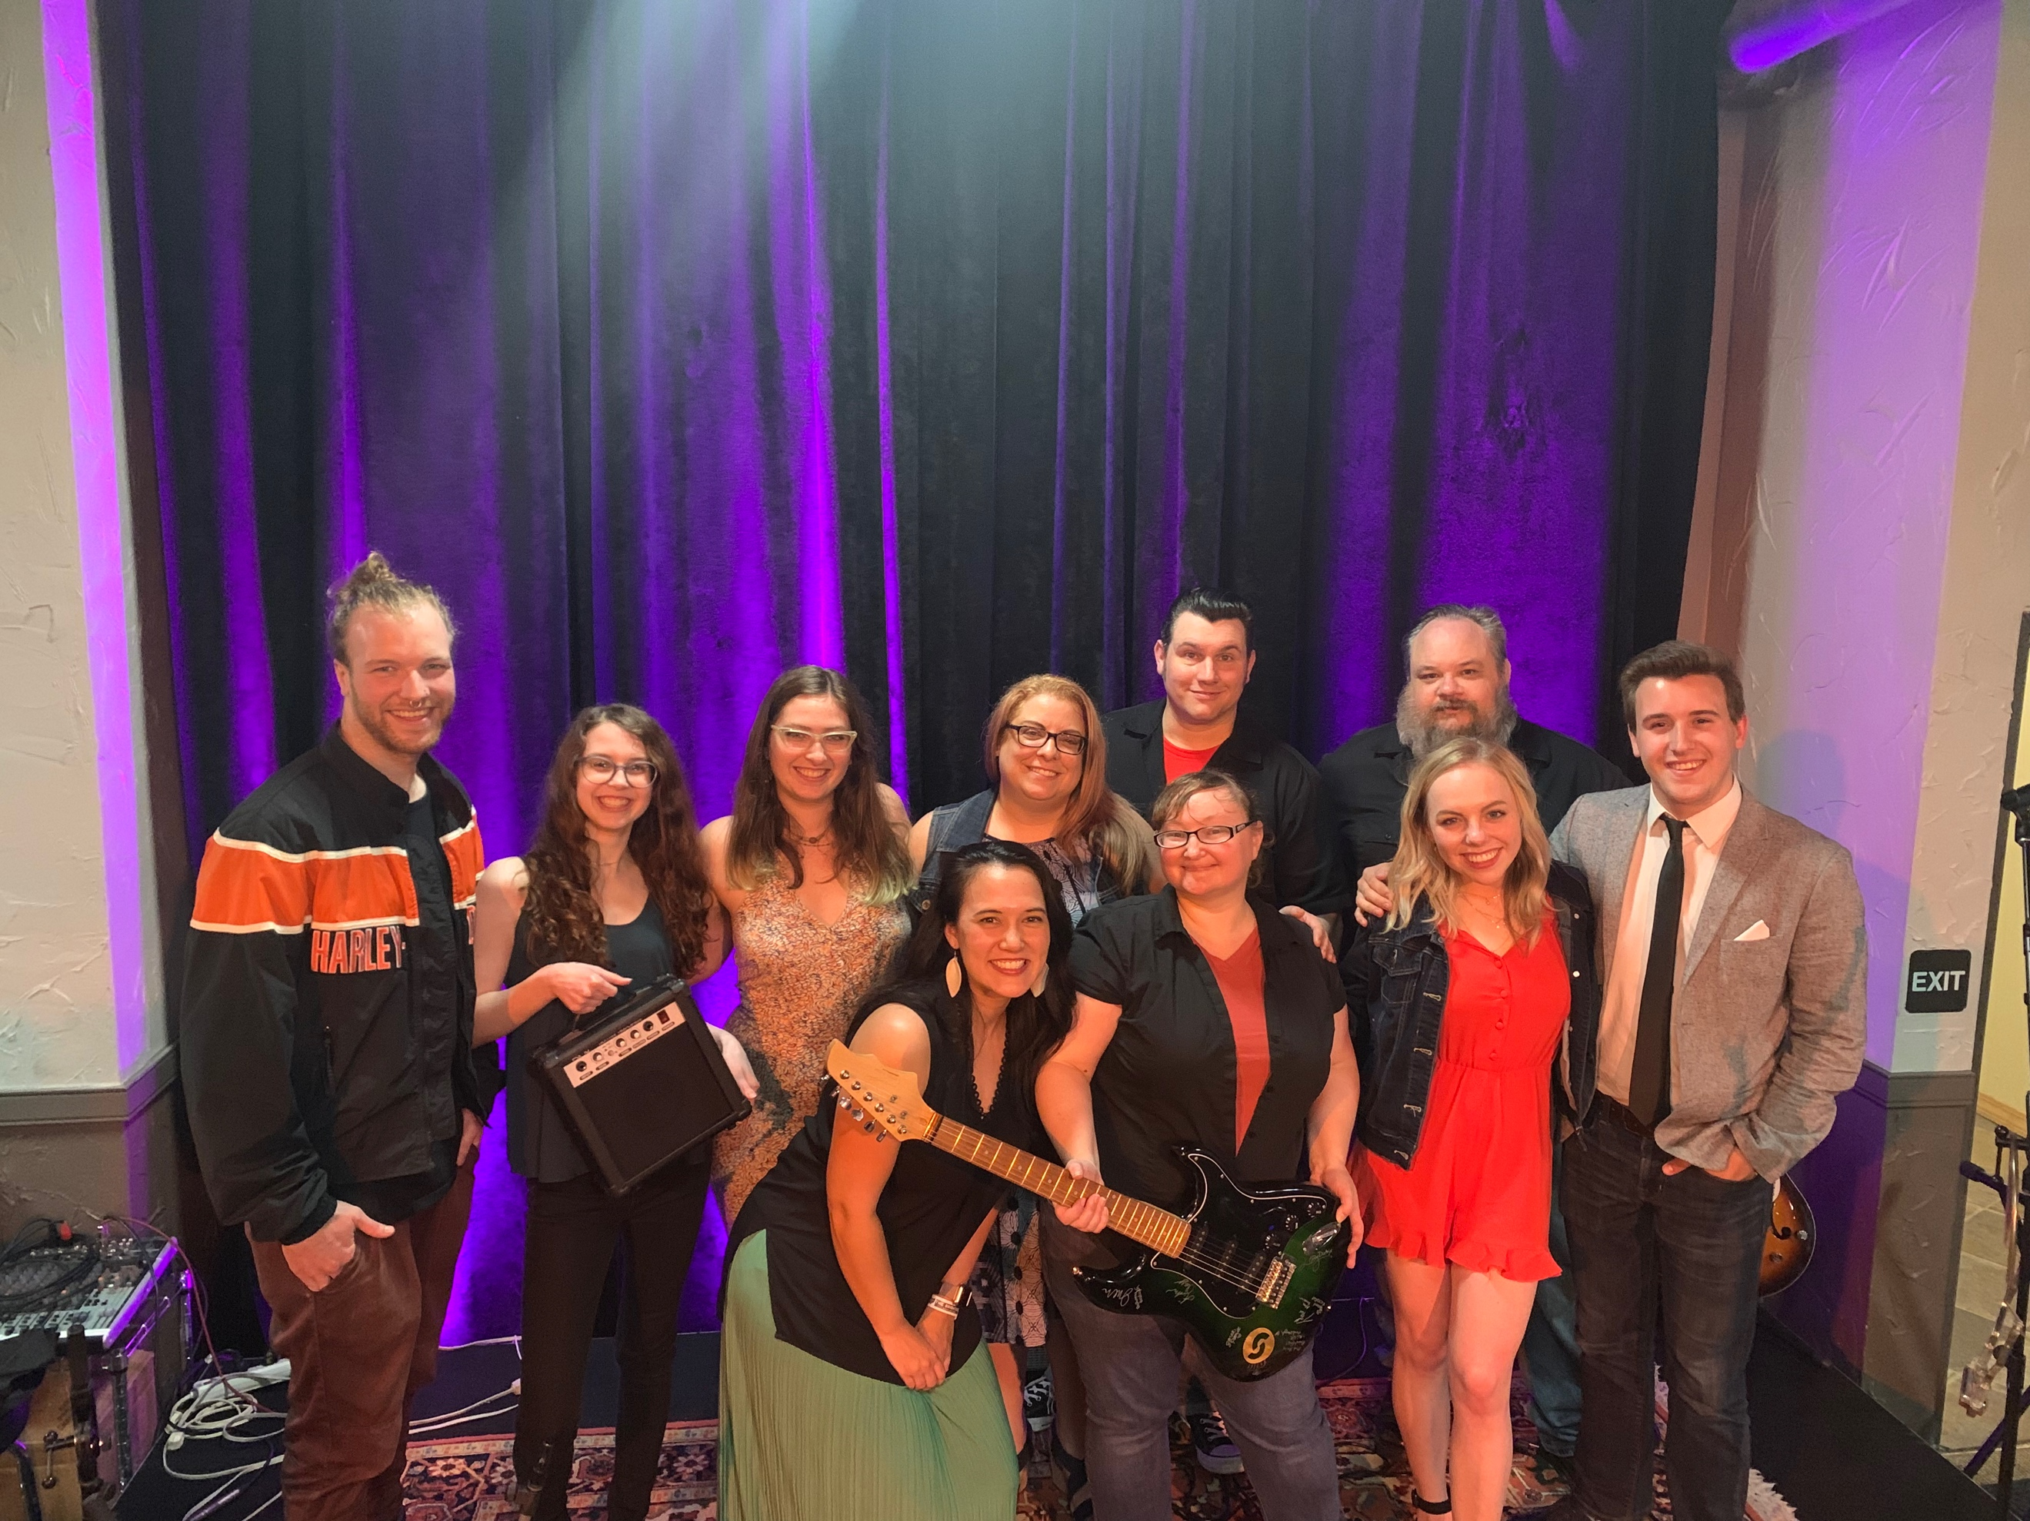
Discuss Campaign Outcomes based on Evaluation Strategies
Evaluation and Metrics
When it comes to looking at our overall goals, I would say we surpassed them. We not only met the $500 goal on Facebook, we exceeded it by $1000! We also met the goal of $500 from ticket sales. Each goal we set was met, and I think that is in part to finding out in the beginning that we need to set realistic goals. We were able to meet up with Franki before the show and get a picture with a really cool big check to show how much we had raised at that point from the Facebook fundraiser. I can’t wait to go back next week with even more funding and the guitar kit!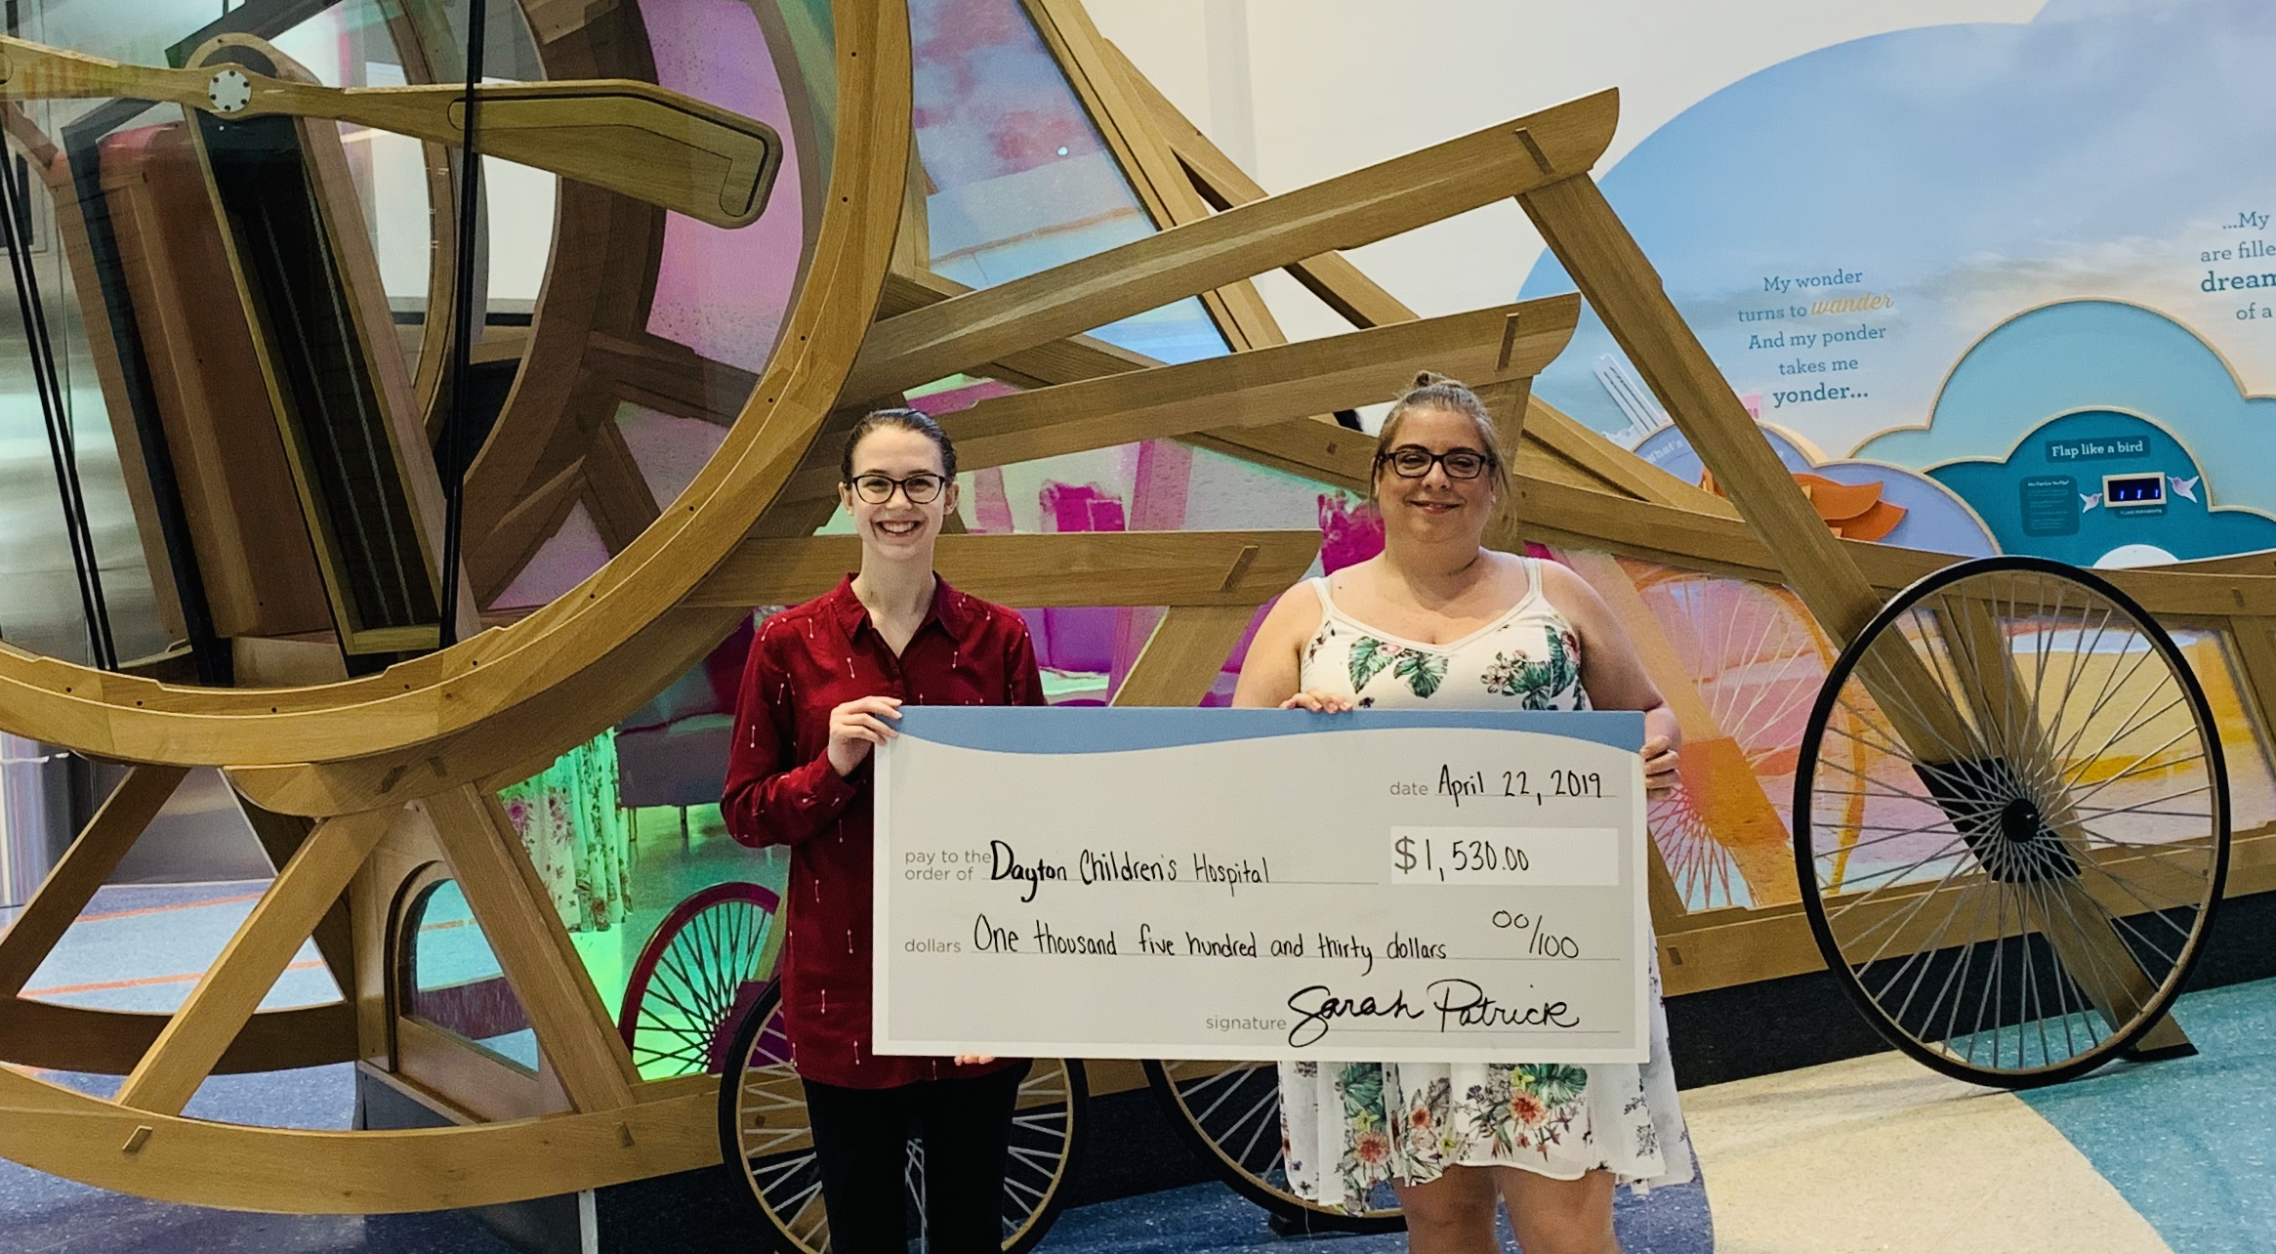
Lessons learned and thoughts for the future
The biggest lesson I learned from this project is perseverance is key. I’ve never been good at hearing the word no, so perhaps that is partially why we managed to pull off the unthinkable. So many celebrities, athletes, and self-made millionaires always ramble on about “being told no”, “this isn’t your thing”, “it will never happen”, and I’ve heard them. I’ve even admired their ability to keep going. This is the first time I have felt just as gratifying as if I was just as well-known as those famous people.
I also learned that deligating doesn’t mean I am not good at multitasking, it means I’m well versed in being a leader. I always feel like if I don’t do all the work, it won’t get done to my standards. It took me a minute, but I realized by giving jobs to the rest of my group, I was a little less stressed. It wasn’t just my project and I had to learn to let them work on things. I have to say it was a little humbling to see how selfish I can be when focusing on a project. I don’t think they minded me taking the lead, and they enjoyed the parts they were responsible for.
Another thing that I realized, the networking is great, but waiting for someone to email you, meet you, give approval on an important part of the project… holding my breath is not recommended. People are busy, and I realized that I’m not the only one pulling them in my direction. They are getting pulled in so many other directions, I may have resolved any issues before they finally reach back out to me.

